Name: Ljiljana Anđelković
E-mail: ljiljana.andjelkovic@pr.ac.rs
Institution: University of Priština in Kosovska Mitrovica, Faculty of Technical Sciences
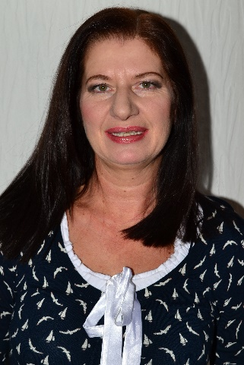 | PhD, assistant professor at the University of Pristina in Kosovska Mitrovica, Faculty of Technical Sciences. She has over 30 years of teaching in: water supply and sewerage systems, fluid mechanics. Research experiences are in water treatments and hydro energetics systems. Participated in 3 national projects of Ministries of the Government of the Republic of Serbia in the field of hydrotechnics.
References (max. 5 relevant references)
1. Purenovic Jelena M, Randjelovic Marjan S, Momcilovic Milan Z, Purenovic Milovan M, Stankovic Novica J, Andjelkovic Ljiljana N (2017) Physicochemically modified peat by thermal and oxidation processes as an active material for purification of wastewaters from certain hazardous pollutants, HEMIJSKA INDUSTRIJA, vol. 71, br. 4, str. 299-306.
2. Perovic Bojan D, Klimenta Jelena Lj, Tasic Dragan S, Peuteman Joan LG, Klimenta Dardan O, Andjelkovic Ljiljana N (2017) Modeling the Effect of the Inclination Angle on Natural Convection from a Flat Plate the Case of a Photovoltaic Module, THERMAL SCIENCE, vol. 21, br. 2, str. 925-938.
3. Andjelkovic Ljiljana N, Purenovic Milovan M, Randjelovic Marjan S, Milicevic Dragan B, Zarubica Aleksandra R, Mitic Marjan P, Tomovic Sreten (2014) Synergy of Hydromechanical and Hydrochemical Parameters in Formation of Solid Deposits in Geothermal and Other Waters, CHEMICAL INDUSTRY & CHEMICAL ENGINEERING QUARTERLY, vol. 20, br. 2, str. 197-206.
4. Kolakovic Srdjan R, Stefanovic Dragoslav S, Milicevic Dragan B, Trajkovic Slavisa, Milenkovic Slobodan S, Kolakovic Slobodan S, Andjelkovic Ljiljana N (2013) Effects of Reactive Filters Based on Modified Zeolite in Dairy Industry Wastewater Treatment Process, CHEMICAL INDUSTRY & CHEMICAL ENGINEERING QUARTERLY, vol. 19, br. 4, str. 583-592.
This project has been funded with support from the European Commission. This publication reflects the views only of the author, and the Commission cannot be held responsible for any use which may be made of the information contained therein.

